MACH4METAL

metalworking machinery
Transito 21
6909 DA BABBERICH Netherlands
Tel. +31 (0)316-247123
Fax: +31 (0)316-247956
info@mach4metal.com
www.mach4metal.com

Bank No : 66.52.13.883
IBAN : NL33 INGB 0665 2138 83
BIC : INGBNL2A

CNC Pressbrake TRUMPF V130

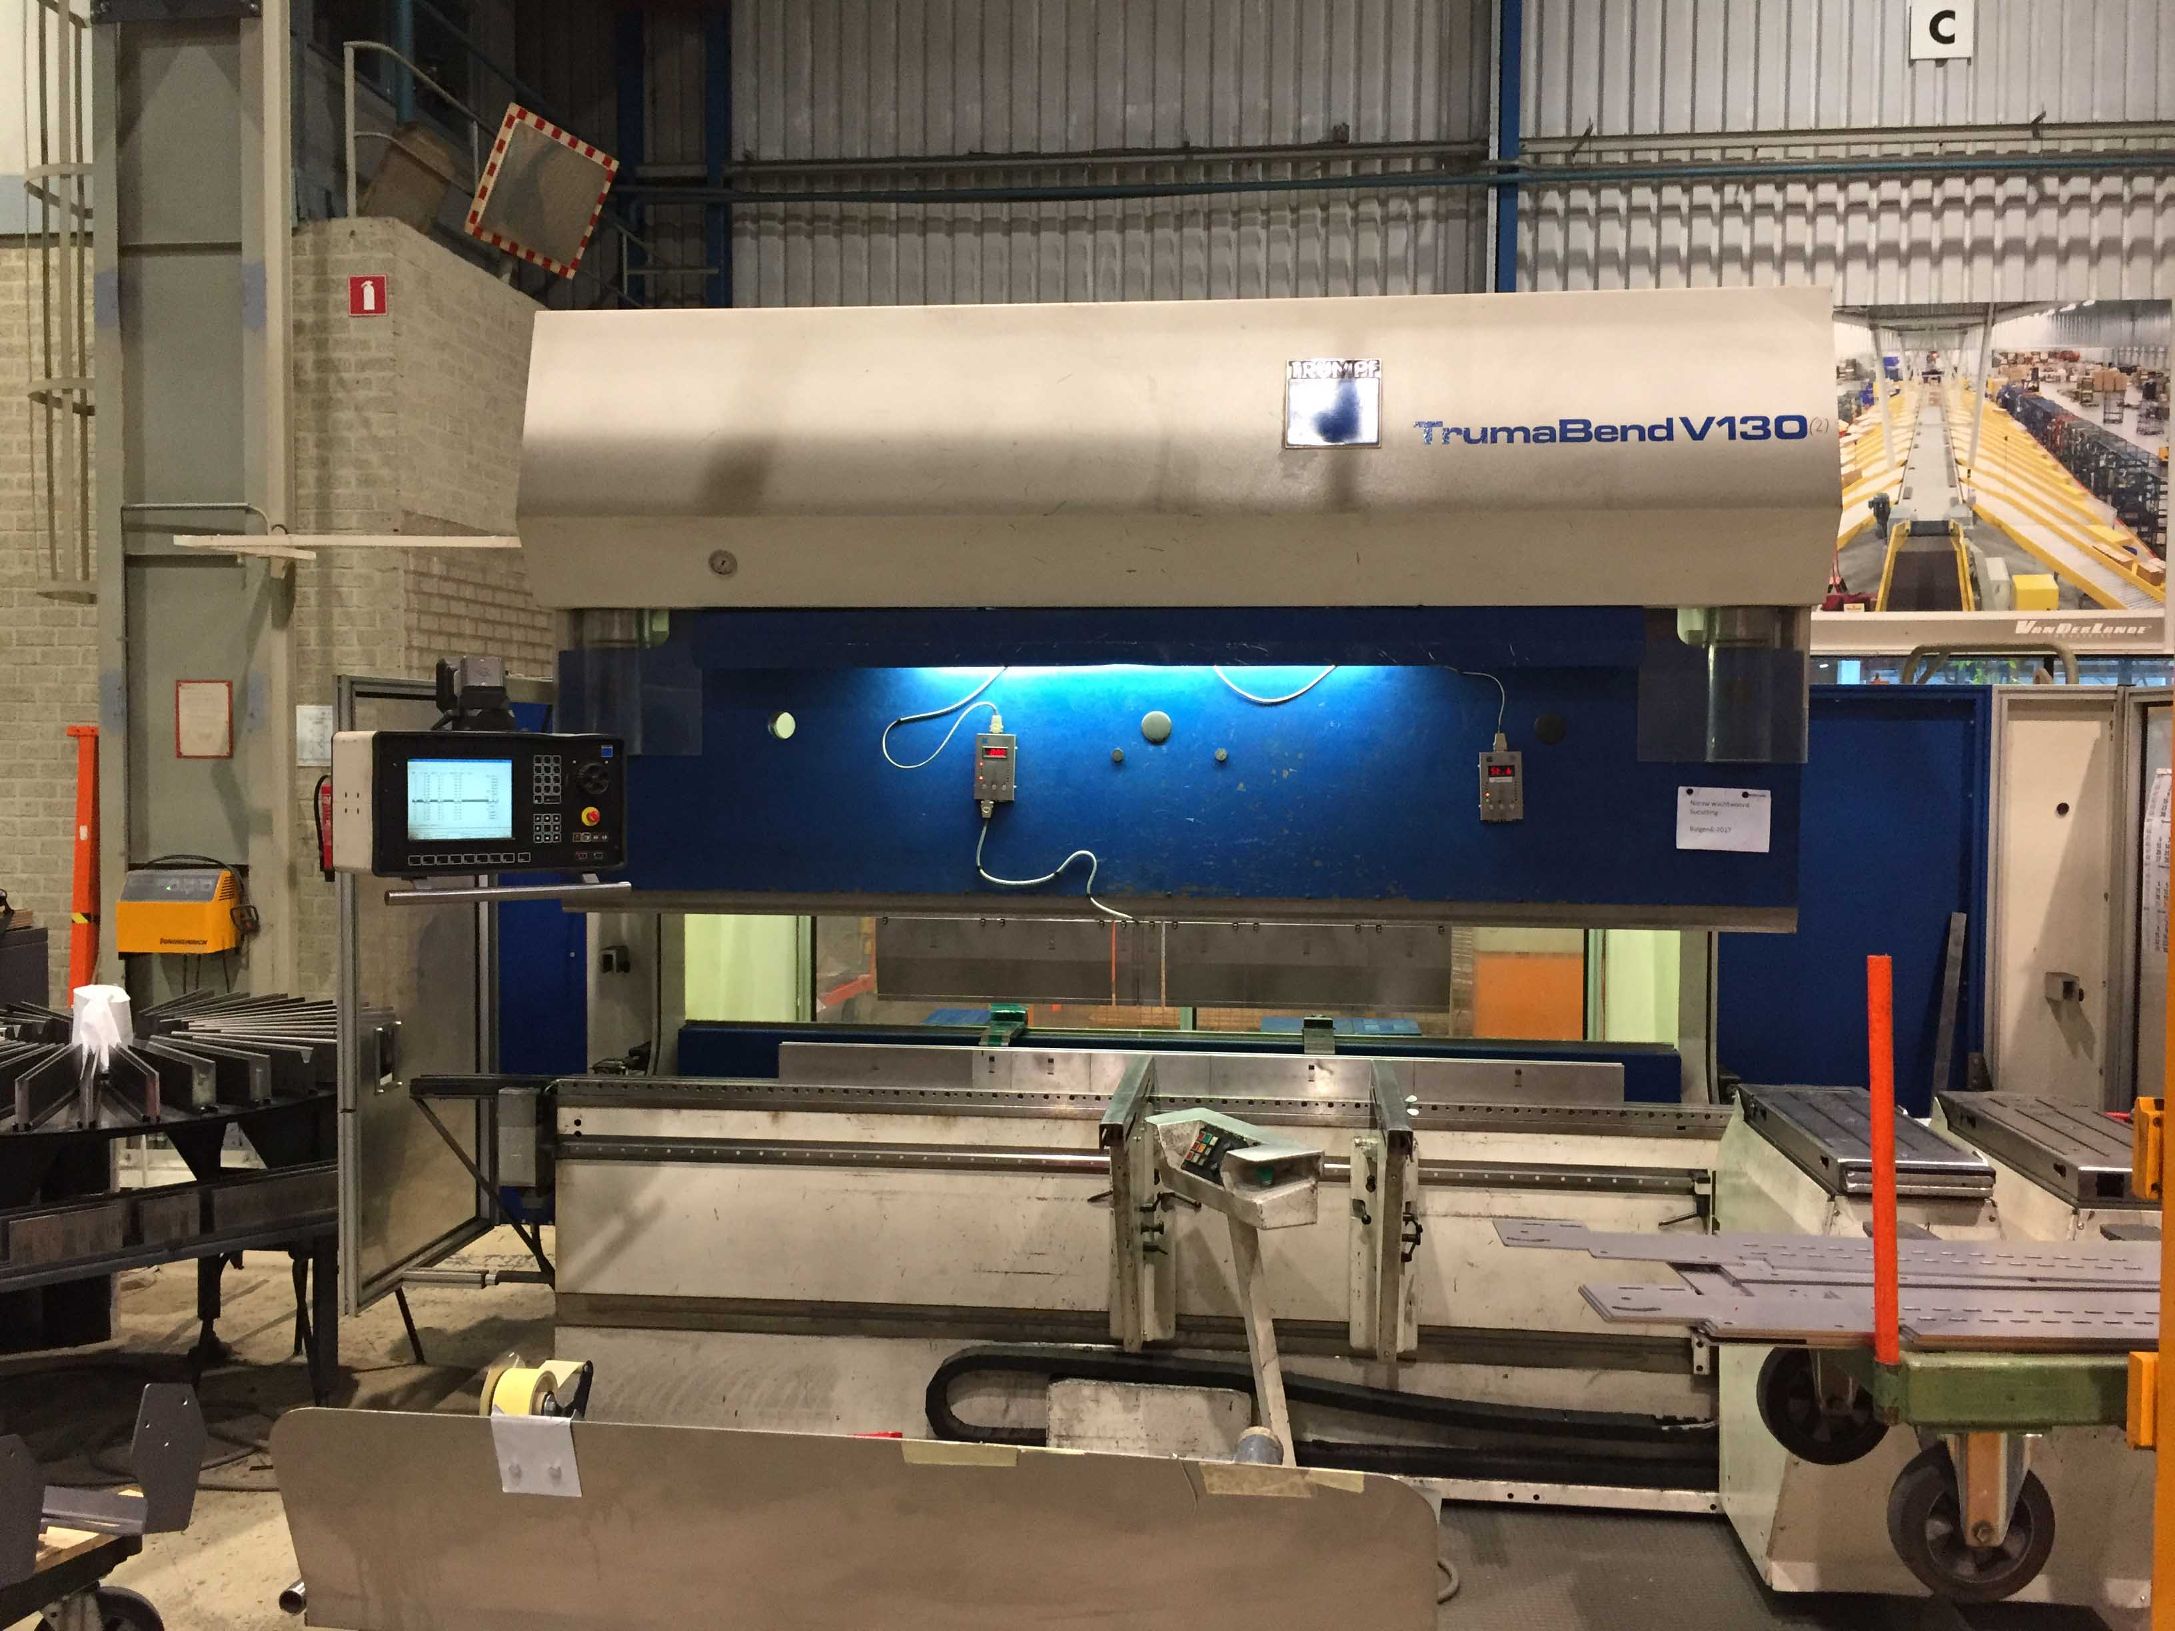
- Make : TRUMPF
- Typ : Trumabend V130
- Mach. No. : B0104 A0039
- Age : 2002

- Max. pressure : 130 T
- Max. bending length : 3.060 mm
- Dis. between column : 2.690 mm

- Stroke : 365
- Dis. table – ram : 535
- Throat : 410
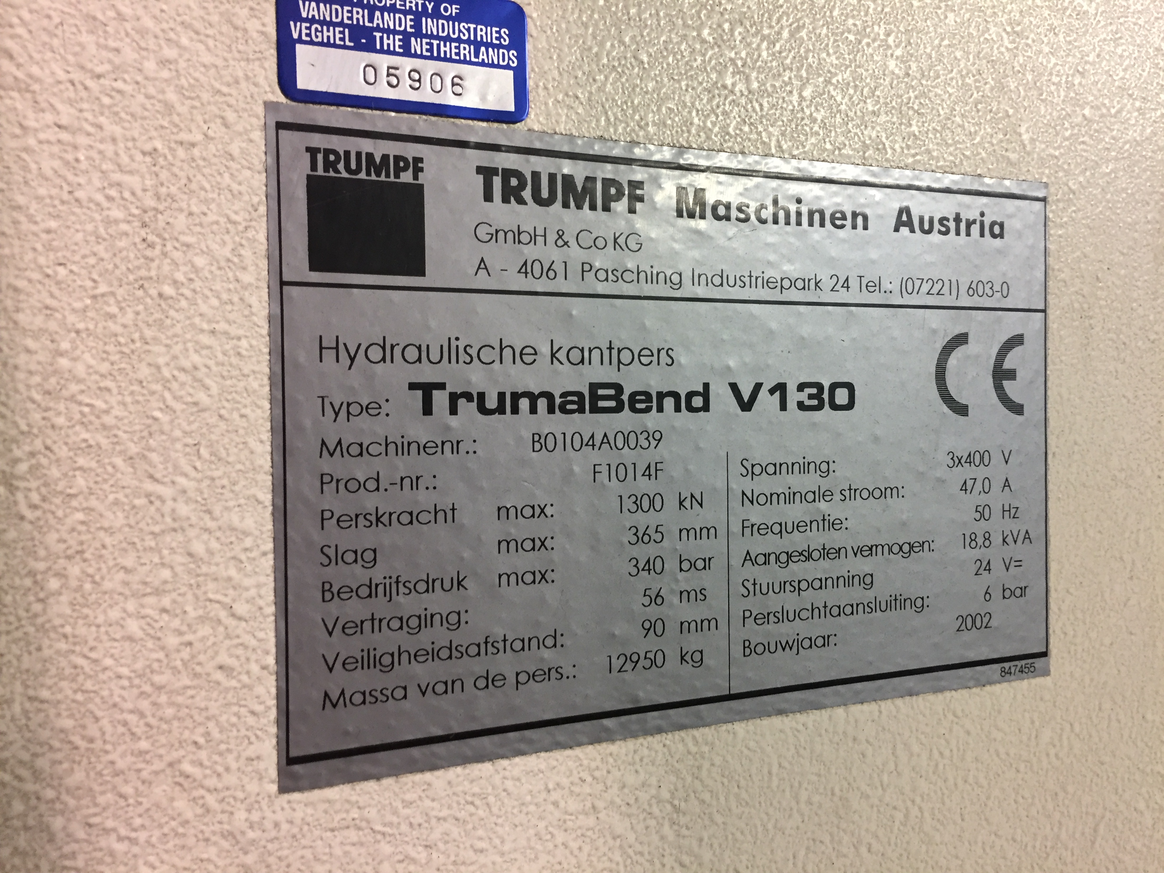
- Approch speeds : 200 mm/M
- Working speeds : 11 mm/M
- Return speeds : 135 mm/M

- DELEM DA..X1/X2/R/Z/T1 & T2
- CNC V – Axis Crowning

- Dimensions
- Length : 3.640
- Width : 2.210
- Height : 2.690
- Weight : 12.950
- Power : 18.5 kW

- Modufix tool clamping

Please Note: The above information has been obtained to the best of our ability and belief from, and from the manufacturers where possible. It is given in good faith, but its accuracy can not be guaranteed. Accordingly, it will not form a representation or constitute contractual terms. We advise you to check any vital details!

